Machine Learning Safety
Exercise sheet 4

Exercise 4.1: Traditional Testing vs. ML Model Testing
Name at least four differences between testing traditional software and testing a machine learning model
Answer
Traditional Software Testing | ML Model Testing
Logic is written by developers | Logic is learned from training data
Outputs are usually deterministic | Outputs are probabilistic and statistical
Bugs mainly come from incorrect program logic | Errors may come from data quality, bias, or distribution shift
Testing focuses on correctness of code | Testing focuses on model generalization and performance
Typically evaluated with pass/fail test cases | Evaluated using metrics such as accuracy, precision, recall, and F1-score

Exercise 4.2: Test Oracles
In traditional software testing, a test oracle determines whether a test has passed or failed.
1. What plays the role of the test oracle in ML model testing?
2. Why is defining a good test oracle particularly difficult for perception tasks?

Answer
1. In ML model testing, the role of the test oracle is typically played by labeled ground-truth data together with evaluation metrics such as accuracy, precision, recall, and F1-score. The model predictions are compared against the expected labels in the test dataset to determine performance.
Unlike traditional software testing, the oracle in ML is often imperfect because labels may contain annotation errors, ambiguities, or subjective decisions. Therefore, ML testing usually relies on statistical evaluation over many test samples rather than exact pass/fail correctness for individual inputs.

2. Defining a good test oracle is particularly difficult for perception tasks because real-world visual data is often ambiguous and noisy. Objects may be partially occluded, far away, blurred, poorly illuminated, or difficult to distinguish from the background.
In addition, labelling perception data is often subjective. Different annotators may disagree on whether an object is present or how it should be classified. Annotation errors and inconsistent labelling can therefore make the ground truth itself imperfect.

Exercise 4.3: From Risk to Metrics
Consider binary pedestrian detection in autonomous driving.
1. Write the empirical risk minimization (ERM) objective using cross-entropy loss. Let
D={(xn,yn)}N n=1 be the training dataset and ℓCE the cross-entropy loss. What is R(θ)?
2. Why do we optimize cross-entropy loss instead of directly optimizing the metric we
care about (e.g., recall on pedestrians)?
3. If a model has low training loss (high accuracy) but low recall on the pedestrian class,
what might explain this? (Hint: think about class imbalance and what accuracy
actually measures.)
4. How would you detect this problem in practice? What metrics would you compute?

Answer
1. Empirical Risk Minimization (ERM) is the principle used to train supervised machine learning models. The goal is to minimize the average prediction error on the training dataset.
The ideal objective is to minimize the true risk:
$$R\left(θ\right)=E_{(X,Y)∼P}\left[L\left(f_{θ}\left(X\right),Y\right)\right]$$
where:
- (P(X,Y)) represents the true real-world data distribution,
- ($f_{θ}\left(X\right)$) is the model prediction,
- and (L) is the loss function.
Since the true data distribution is unknown in practice, we approximate the true risk using the available training dataset (D={(x_n,y_n)}_{n=1}^{N}).
Using cross-entropy loss, the empirical risk is defined as:
R^(θ)=N1​∑n=1N​ℓCE​(fθ​(xn​),yn​)
where:
- (N) is the number of training samples,
- (x_n) is the input sample,
- (y_n) is the corresponding ground-truth label,
- (fθ​(xn​)is the model prediction,
- And ℓCE is the cross-entropy loss function.
The objective of training is to find model parameters (θ​) that minimize the empirical risk over the dataset.

2. We optimize cross-entropy loss instead of directly optimizing metrics such as recall or F1-score because cross-entropy is differentiable and therefore compatible with gradient-based optimization methods such as backpropagation and gradient descent.
Metrics such as recall, accuracy, or F1-score depend on discrete threshold decisions and are generally non-differentiable. This makes them difficult to optimize directly during neural network training.

3. A model can achieve low training loss and high overall accuracy while still having low recall on the pedestrian class because of class imbalance in the dataset. In autonomous driving datasets, most images may not contain pedestrians, meaning the negative class is much more common than the positive class.
Accuracy measures the proportion of all correct predictions, so a model can obtain high accuracy simply by predicting the majority class correctly most of the time. However, this may still result in many missed pedestrian detections (false negatives).
As a result, the model may appear to perform well overall while actually performing poorly on the safety-critical pedestrian class. This demonstrates why accuracy alone can be misleading for imbalanced datasets and why class-specific metrics such as recall are important in safety-critical ML systems.

4. This problem can be detected by evaluating class-specific metrics instead of relying only on overall accuracy. In practice, the model should be tested on an independent validation or test dataset and analyzed using a confusion matrix.
The most important metrics to compute are:
- Precision
- Recall
- F1-score
- Per-class accuracy
For pedestrian detection, recall is especially important because low recall indicates many false negatives, meaning pedestrians are being missed by the system.
A confusion matrix can further help identify whether the model mainly produces false positives or false negatives. This provides a more detailed understanding of model behavior than overall accuracy alone, especially for imbalanced safety-critical datasets.

Exercise 4.4: Distribution Shift Types
Consider the following three scenarios involving the CARLA autonomous driving model
(trained on sunny daytime data):
1. The model is deployed during winter, when roads are often wet and the sun is at a
low angle, creating glare in camera images.
2. A new city zone is added to the test route where 60% of road users are cyclists- a
class that was rare (< 5%) in the original training data.
3. The city replaces all old traffic light housings with a new, slimmer design that the
model has never seen.
For each scenario:
a) Identify which type of distribution shift applies (covariate shift, label shift, or concept
shift). Justify your answer.
b) Explain what effect you would expect on model performance.
c) Suggest one mitigation strategy.

Answer
Scenario 1
a) Type of Distribution Shift:
This scenario represents covariate shift because the input distribution changes due to winter weather, wet roads, and glare effects, while the underlying relationship between objects and labels remains unchanged.
b) Expected Effect on Model Performance:
The model performance would likely decrease because the visual appearance of the environment differs from the sunny daytime training conditions. Glare, reflections, and wet roads may reduce visibility and make object detection less reliable.
c) Mitigation Strategy:
One mitigation strategy is to include more diverse environmental conditions during training, such as winter, rain, and glare scenarios.

Scenario 2
a) Type of Distribution Shift:
This scenario represents label shift because the proportion of different classes changes between training and deployment. Cyclists were rare in the training dataset but become very common in the new deployment environment.
b) Expected Effect on Model Performance:
The model may perform poorly on cyclist detection because cyclists were underrepresented during training. This could lead to lower recall and increased misclassification rates for cyclists in the new city zone.
c) Mitigation Strategy:
One mitigation strategy is to collect and include more cyclist examples in the training dataset. Techniques such as class balancing or resampling could help improve performance on cyclist-heavy environments.

Scenario 3
a) Type of Distribution Shift:
This scenario represents concept shift because the relationship between the input appearance and the target label changes. The model was trained on older traffic light designs, while deployment introduces a new visual design that the model has never seen before.
b) Expected Effect on Model Performance:
The model may fail to correctly recognize the new traffic light housings, leading to lower recall and increased false negatives. Since traffic lights are safety-critical objects, this could negatively affect driving decisions at intersections.
c) Mitigation Strategy:
One mitigation strategy is to retrain or fine-tune the model using data containing the new traffic light designs. Continuous dataset updates and periodic model retraining can help adapt the system to changing real-world environments.

Exercise 4.5: ODD Coverage with k-Projection Coverage
You defined an ODD in Exercise Sheet 2. Now assess how well your test set covers this
ODD using k-projection coverage.
1. Describe in your own words what k-projection coverage measures and why it is a
useful metric for ODD coverage.
2. Download the implementation from https://github.com/kkirchheim/odd-coverage
and compute the k-projection coverage of your test set for k ∈ {1,2,3}.
3. How does coverage change with increasing k? What does this tell you about the
adequacy of your test set?

Answer
1. k-projection coverage checks how well a test dataset includes different combinations of ODD conditions. Instead of testing every possible combination, it only looks at combinations of size (k).
For example:
- (k=1): checks if each condition appears at least once
- (k=2): checks if every pair of conditions appears
- (k=3): checks combinations of three conditions
This is useful because testing all possible combinations can become too large and difficult very quickly. k-projection coverage gives a simpler and more practical way to make sure important situations are included in the dataset.
In ML safety, this helps ensure that important real-world scenarios are tested, which increases confidence that the model will behave safely and reliably.

2. To compute the k-projection coverage, the ODD was first converted into a set of categorical dimensions:
Dimension | Values
Weather | sunny, rain/fog/snow
Lighting | day, night
Camera | normal, damaged
Scene | urban, unmapped
Speed | ≤50 km/h, >50 km/h
Using the provided k-projection coverage implementation, the following results were obtained:
k | Coverage | Covered Points | Total Points
1 | 0.50 | 5 | 10
2 | 0.25 | 10 | 40
3 | 0.125 | 10 | 80

3. The k-projection coverage decreases as the value of (k) increases.
The computed results were:
- (k=1): coverage = 0.50
- (k=2): coverage = 0.25
- (k=3): coverage = 0.125
This behaviour is expected because larger values of (k) require coverage of increasingly complex combinations of ODD conditions. While the dataset covers some individual conditions, it contains very few combinations of different environmental situations.
The results indicate that the test set mainly represents a narrow subset of the defined ODD, specifically sunny daytime urban driving conditions. Many combinations involving rain, nighttime driving, damaged cameras, or unmapped environments are not represented at all.
Therefore, the current test set does not provide comprehensive coverage of the full ODD. This limits confidence in the robustness and safety of the models under diverse real-world deployment conditions.

Exercise 4.6: Designing a Test Suite from Safety Constraints Refer back to Exercise 2.7 in Sheet 2, where you derived safety constraints from Unsafe Control Actions (UCAs). For each model-level constraint, design one test case using the following structure:

Answer

Constraint ID | Constraint | Test Input Description | Expected Output | Pass Criterion
UCA-3 | Emergency braking commands must be issued within a safe response time | A test image sequence containing a pedestrian suddenly appearing in front of the vehicle within critical stopping distance | The pedestrian is detected quickly and the braking command is triggered without excessive delay | The pedestrian is correctly detected and the braking response occurs within the defined safe response time
UCA-4 | Emergency braking should only be activated when obstacle detection is reliable | Test images containing road scenes without pedestrians or obstacles, including shadows and non-dangerous objects | No emergency braking command should be triggered for non-critical objects or false detections | The system avoids false positive obstacle detections and does not trigger unnecessary emergency braking

Exercise 4.7: Per-Class Evaluation
Evaluate each of your three models on the provided test set.
1. Compute and report precision, recall, and F1-score for each model.
2. Plot a confusion matrix for each model.
3. Which model has the lowest recall? Is this the model you expected to be hardest based on your hazard analysis? Exercise 4.7: Per-Class Evaluation
4. Based on a safety argument: what minimum recall would you require for the pedestrian model before considering deployment? Justify your threshold.

Answer
1.
Model | Precision | Recall | F1-Score
Pedestrian Classifier | 0.377 | 0.629 | 0.471
Vehicle Classifier | 0.932 | 0.920 | 0.926
Traffic Light Classifier | 0.951 | 0.952 | 0.951

2. Pedestrian
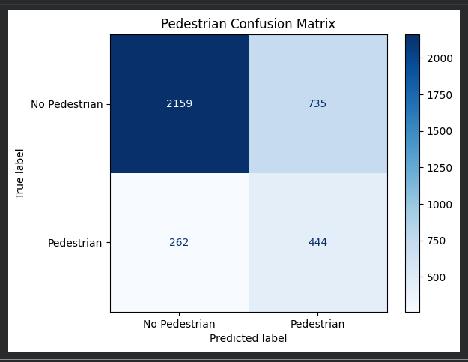
Vehicle
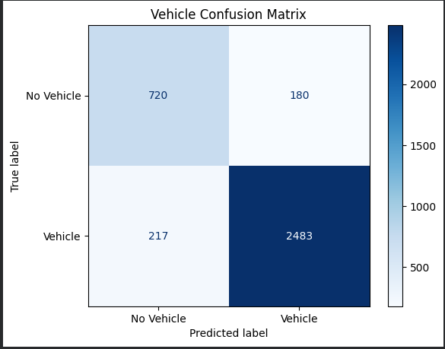
Traffic lights
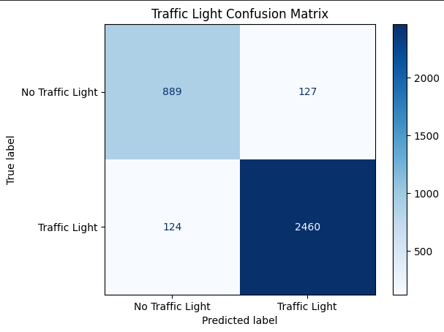

3. The pedestrian classifier had the lowest recall among the three models.
This result was expected based on the earlier hazard analysis. Pedestrian detection is one of the most safety-critical perception tasks because missed pedestrians can directly lead to collisions and severe injuries.
In addition, pedestrian detection is generally more difficult than vehicle or traffic light detection because pedestrians are smaller, more visually variable, and may be partially occluded or less frequent in the dataset. This makes achieving high recall more challenging.The results therefore confirm the importance of evaluating each class separately instead of relying only on overall performance metrics.

4. For a safety-critical pedestrian detection system, I would require a minimum recall of at least 95% before considering deployment.
The reason is that false negatives in pedestrian detection are extremely dangerous because missing a pedestrian could directly lead to a collision and severe injury. In autonomous driving, detecting pedestrians reliably is generally more important than avoiding occasional false positives such as unnecessary braking.
The threshold should be derived from the hazard analysis and safety requirements rather than from the model’s currently achieved performance. Since pedestrian detection is one of the most safety-critical perception tasks, a high recall requirement is necessary to reduce the probability of missed detections.
The current pedestrian model recall of approximately 63% would therefore not be sufficient for safe real-world deployment.

